**Lab 12B exercise –CRUD**

Objective:

Practice creating a table and performing basic SQL operations (INSERT, SELECT,

UPDATE, DELETE) on it.

Scenario:

You're tasked with managing a simple table for a library system that tracks books.

Each book record includes:

• An id (automatically generated),

• A title,

• The author,

• The year_published.

Tasks:

1. Create the Table

Create a table named books with the following structure:

• id – SERIAL PRIMARY KEY

• title – VARCHAR(100) NOT NULL

• author – VARCHAR(100) NOT NULL

• year_published – INT

-- create table books

CREATE TABLE books (

id SERIAL PRIMARY KEY,

title VARCHAR(100) NOT NULL,

author VARCHAR(100) NOT NULL,

year_published INT

);

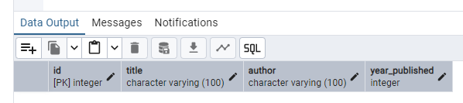

2. Insert Records

Insert the following records into the books table:

title author year_published

The Great Gatsby F. Scott Fitzgerald 1925

Animal Farm George Orwell 1945

To Kill a Mockingbird Harper Lee 1960

Brave New World Aldous Huxley 1932

-- insert data

INSERT INTO books (id, title, author, year_published)

VALUES

(1, 'The Great Gatsby', 'F. Scott Fitzgerald', 1925),

(2, 'Animal Farm', 'Harper Lee', 1960),

(3, 'To Kill a Mockingbird', 'Harper Lee', 1960), --- here I made mistakes ----

(4, 'Brave New World', 'Aldous Huxley', 1932 );

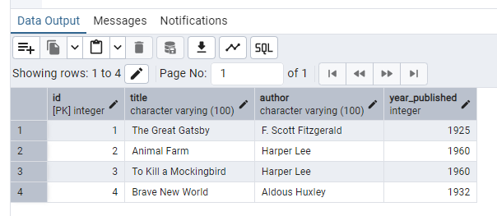

UPDATE books

SET author = 'George Orwell', year_published = 1945

WHERE id=2;

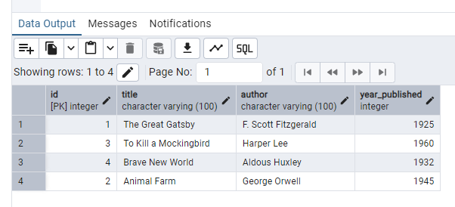

3. Read Data

Write SQL queries to:

• Select all books.

• Select books where the author is 'George Orwell'.

SELECT * FROM books

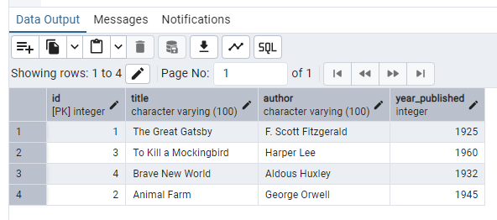

SELECT * FROM books

WHERE author = 'George Orwell';

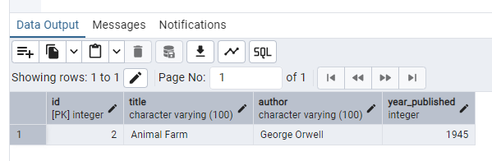

4. Update Data

Update the year_published of Brave New World to 1931.

UPDATE books

SET year_published = 1931

WHERE title = 'Brave New World';

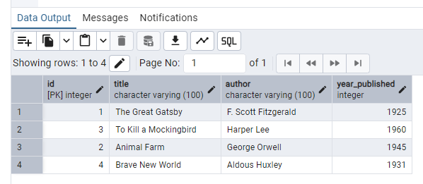

5. Delete Data

Delete the record for To Kill a Mockingbird.

DELETE FROM books

WHERE title = 'To Kill a Mockingbird'

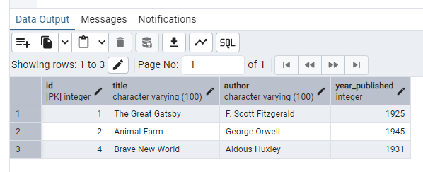

6. View Final Table

Select all records from the books table to verify your changes.

Bonus Challenge (Optional)

• Add a new column genre to the books table.

• Update the genre for each book.

• Select all books grouped by genre.

SELECT * FROM books

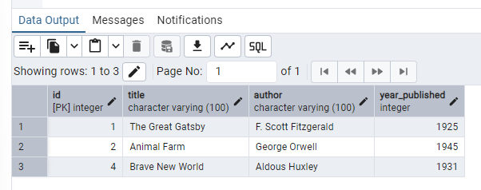

-- bonus

-- add new column genre to books table

ALTER TABLE books

ADD COLUMN genre VARCHAR(30);

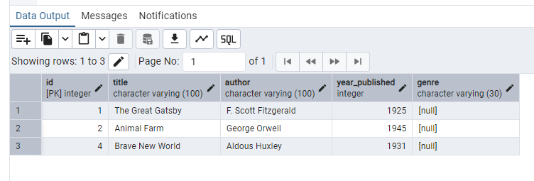

-- update genre for each book

-- select all books grouped by genre

UPDATE books

SET genre = 'Literature'

WHERE title = 'The Great Gatsby';

UPDATE books

SET genre = 'Fiction'

WHERE title = 'Animal Farm';

UPDATE books

SET genre = 'Horror'

WHERE title = 'Brave New World';

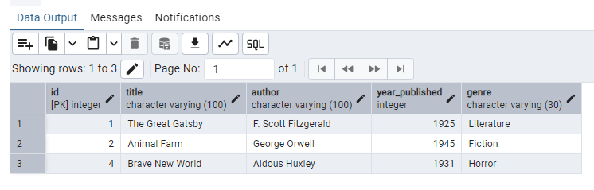

-- select all books grouped by genre

SELECT genre FROM books GROUP BY genre;

